**ASSIGNMENT # 1**

**CS-871: MACHINE LEARNING**

**SHORT NOTE ON AI GARTNER CYCLE 2025**

**&  
GENERATE AND IMAGE USING CREATIVE PROMPT USING ANY TEXT TO IMAGE GENERATER AI TOOL**



**SUBMITTED BY:**

**Muhammad Soban Shaukat**

*(Registration No: 00000538822)*

**Master of Science in  
Artificial Intelligence**

*Fall-2025*

**SUBMITTED TO:**

**Dr. Ai Hassan**

*Prof, CEME, NUST*

**Date of Submission: 24-September-2025**

**Department of Computer Sciences and Engineering, CEME. National University of Sciences & Technology (NUST), Rawalpindi (2025)**

**QUESTION 1(a)**

**Write a short note on AI on the Gartner Hype Cycle of 2025**

**ANSWER:**

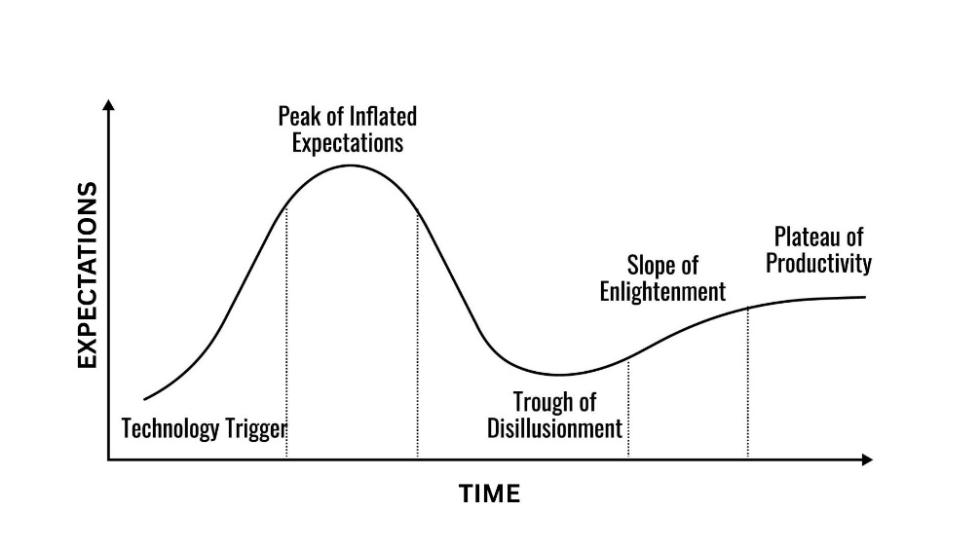The **Gartner Hype Cycle** is a graphical representation and methodology developed by the research and consulting firm Gartner to track the maturity, adoption, and social application of specific technologies. It provides a visual and conceptual framework for understanding the lifecycle of a technology from its initial breakthrough to mainstream adoption.

The cycle has five phases:

* **Innovation Trigger**, where new technology gets initial attention
* **Peak of Inflated Expectations**, where early hype leads to unrealistic projections.
* **Trough of Disillusionment**, as interest wanes and early projects fail to deliver.
* **Slope of Enlightenment**, where the technology's benefits become better understood and more realistic applications emerge.
* 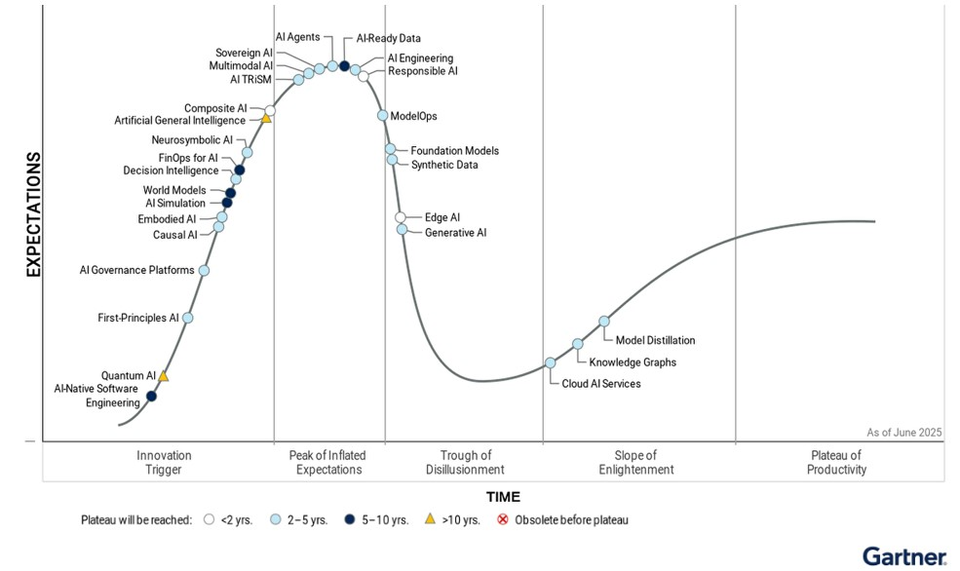**Plateau of Productivity**, where the technology is widely adopted and its value is clearly demonstrated.

**The Overall Graph Explained**

* **Y-Axis (Expectations)** & **X-Axis (Time)**
* **The Curve:** The gray curve shows the typical path technology takes. It starts low, shoots up with a lot of excitement, falls into a period of disappointment, and then slowly climbs back up to become a useful tool.

Legend tells us how long it will take for each technology to reach the **Plateau of Productivity**.

* ⚪ **Empty circle:** It will be widely useful in **less than 2 years**.
* 🔵 **Light blue circle:** It will be widely useful in **2 to 5 years**.
* ⚫ **Dark blue circle:** It will be widely useful in **5 to 10 years**.
* **Yellow triangle:** It will be widely useful in **more than 10 years**.
* ❌ **Red X:** It will become **obsolete** before it's ever widely useful.

**Explanation of some Phases and Technologies**

**1. Innovation Trigger**

This is where new technology is just starting out, and only a few people know about it. It's the beginning of the hype.

* **Quantum AI ( ):** This is a futuristic idea of combining quantum computing with AI. It's a very long way from being a reality.
* **AI Simulation (🔵):** This technology uses computers to create fake worlds or environments where AI can learn and practice safely.
* **FinOps for AI (🔵):** This is a way of managing the money spent on AI projects to make sure they are efficient and not too expensive.
* **Artificial General Intelligence ( ):** This is the goal of AI to create a computer that can do anything a human can do. It's a very long way off.

**2. Peak of Inflated Expectations**

This is where all the excitement is. The technology is new, and everyone thinks it will change everything.

* **AI Agents (🔵):** These are autonomous programs that can act and make decisions on your behalf, like a super-smart digital assistant.
* **AI-Ready Data (🔵):** This is the idea of getting data ready for AI to use easily. Everyone is excited about this, but it's often harder than it looks.
* **Responsible AI (**⚪**):** This is the set of rules and practices to make sure AI is used ethically and safely. It's a major topic of conversation right now.

**3. Trough of Disillusionment**

This is the low point. The initial excitement has faded, and people have realized the technology is harder to use or not as magical as they first thought.

* **Foundation Models (🔵):** These are massive AI models that can be used for many different tasks. They are the base for many popular tools like ChatGPT.
* **Generative AI (🔵):** This is the AI that can create new text, images, and music. It's still very exciting, but it's moving down the curve as people realize its limitations and challenges.

**4. Slope of Enlightenment**

This is the phase where technology starts to mature. People understand what it's really good for and how to use it effectively. The usefulness starts to grow again.

* **Knowledge Graphs (🔵):** This is a way of organizing data by connecting things and showing how they relate to each other. It's a useful technology, but it’s been around for a while, and its hype has gone down.
* **Cloud AI Services (🔵):** This is when companies offer AI tools that you can use over the internet. These are becoming more common, and the initial hype has passed.

**5. Plateau of Productivity**

This is the final stage where technology is a normal, useful part of everyday life. The benefits are clear, and it’s being used widely.

* As of June 2025, **no AI technologies** are shown to have reached this final plateau. This shows that the field of AI is still very much in its early, evolving stages.

1. **Do google searches/ chat GPT but then WRITE IN YOUR OWN WORDS, what you understand of at least 02 technologies of your interest**

***NOTE****: Each technology should be explained in 200-400 words*

1. **AI Agents**

An AI agent is a new software program that employs artificial intelligence to accomplish a particular task and perform these tasks independently. Contrary to a conventional chatbot that simply adheres to a set of predefined guidelines, an AI agent possesses the ability to reason, plan, and take actions as well as adjust to its surroundings. Its essence is to perceive the world with the help of sensors, user input or APIs to determine the set of action that will be best and execute it without requiring human attention. These agents are typically constructed upon top of large language models LLM which serve as the brains of such agents enabling them to comprehend natural language and decompose complicated requests into smaller, solvable ones.

High level of autonomy is the primary distinction between an AI agent and other AI tools. An AI agent can act on its own whereas an AI assistant such as Siri or Alexa will do that after a command is given. To illustrate, a customer service representative can not only respond to a customer with a question but also access the information, make changes to his/her account and send a follow-up email, without any human permission. They even can collaborate with other agents to resolve more complex issues such as optimizing the supply chain. Due to their ability to accomplish multi-step processes and decision-making, AI agents are regarded as the next significant milestone in AI, as they go beyond content generation to represent multi-step processes being fully automated.

1. **Responsible AI**

Responsible AI is an all-encompassing plan of designing, testing, and implementing AI systems in an ethical, safe, and reliable manner. It is a collection of ideals that informs the complete lifecycle of an AI project, the original concept up to its ultimate application. The primary objective is to make sure that AI technologies follow human values and are not harmful to people. It is gaining more significance with the various ways in which AI is applied in the most crucial domains of healthcare, finance, and hiring in which an AI decision can significantly affect the lives of people.

The major principles of Responsible AI are:

* **Fairness and Inclusivity:** This implies that AI should be set in a way that it does not discriminate individuals based on their gender, ethnicity, and other attributes. Data that is used to train the AI must not be biased.
* **Accountability**: The individuals and institutions that design and use AI systems should be responsible regarding the functionality of the systems. Human control needs to exist, and the decision-makers of AI should be indicated.
* **Transparency:** one should be capable of seeing how an AI system made a particular decision. This explicable AI can help build trust and identify and correct errors.
* **Privacy and Security**: AI systems should preserve the sensitive data that they operate with and adhere to all laws on privacy.

By adhering to these principles, companies will be able to gain the trust of the population, decrease legal, digital security and financial risks as well as develop AI that will benefit all people.

**QUESTION 1(b)**

**Be creative and generate an image using any text to image Generative AI tool**

* **Submit the image and also share it on WhatsApp group. Let us find out who generates the most creative image**

***NOTE:*** *only your best image please*

* **Name the tool and the text prompt you used for image generation.**

**ANSWER:**

**TOOL:** NANO BANANA - GEMINI AI IMAGE GENERATOR & PHOTO EDITOR BY GOOGLE DEEP MIND **PROMPT: (**given Below**)**

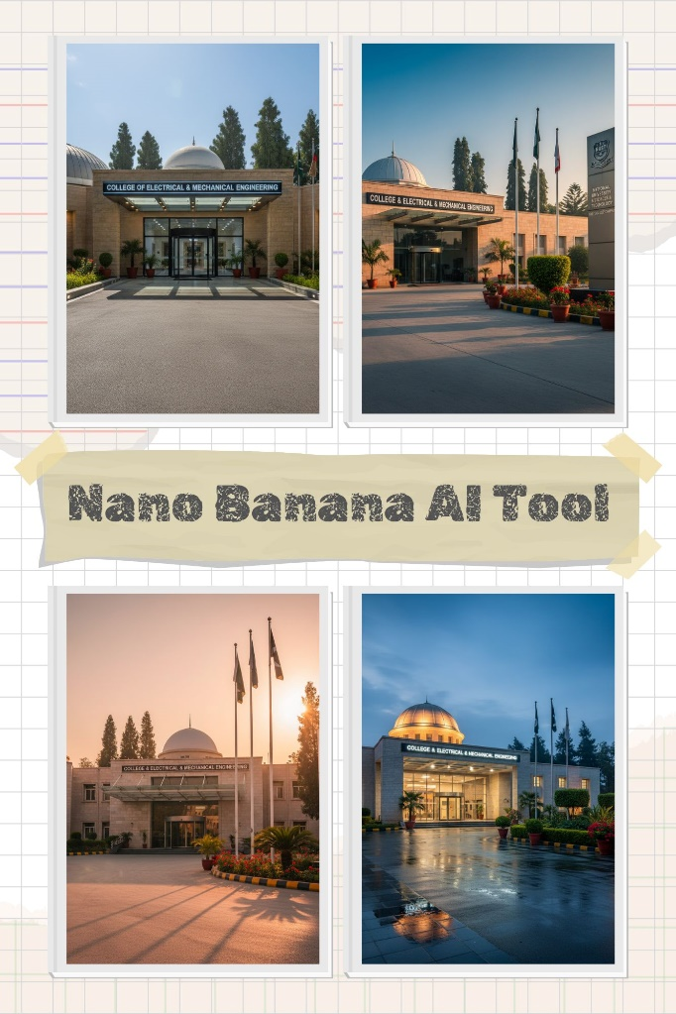**Output:**

**PROMPT:**

{

**"scene"**: "main entrance of College of Electrical & Mechanical Engineering (CEME), NUST, Rawalpindi, Pakistan",

**"time"**: "midday with bright clear sunlight",

**"subjects"**: [

{

**"type"**: "entrance block",

**"facade"**: {

**"material"**: "light sandstone or pale brick",

**"details"**: "crisp mortar lines, subtle color variation, clean and smooth textures enhanced by sunlight",

**"lighting"**: "natural bright sunlight casting sharp, well-defined shadows and highlighting architectural details"

},

**"canopy"**: {

**"material"**: "crystal-clear glass panels",

**"structure"**: "sleek metal mullions",

**"reflections"**: "clear sky reflections and bright sun glints"

},

**"main_doors"**: {

**"style"**: "modern revolving doors framed by polished metalwork",

**"roof"**: {

**"shape"**: "prominent centered white dome",

**"material"**: "smooth plaster with soft specular highlights",

**"illumination"**: "sunlit with subtle highlights emphasizing dome curvature"

}

},

**"left_structures"**: [

{

**"type"**: "large gray dome",

**"visibility"**: "partially visible on left",

**"material"**: "matte concrete with metallic gray finish",

**"details"**: "softly curved surface with sunlight accentuating textures and shadows"

}

],

**"signage"**: [

{

**"location"**: "above entrance",

**"type"**: "elegant fascia sign",

**"text"**: "COLLEGE OF ELECTRICAL & MECHANICAL ENGINEERING",

**"font"**: "clean uppercase sans-serif with perfect kerning",

**"lettering"**: "white on black band with crisp sharp edges reflecting sunlight"

},

{

**"location"**: "right side",

**"type"**: "tall vertical column sign",

**"base_color"**: "pristine white",

**"logo"**: "polished NUST crest atop the column",

**"text"**: "NATIONAL UNIVERSITY OF SCIENCES & TECHNOLOGY EME COLLEGE CAMPUS",

**"text_case"**: "stacked uppercase text perfectly aligned and kerned",

**"lighting"**: "bright natural light with balanced highlights and shadows"

}

]

}

],

**"foreground"**: {

**"driveway"**: {

**"material"**: "smooth, light gray asphalt/concrete",

**"details"**: "sunlit surface with faint tire sheen and subtle shadow play, flawlessly maintained"

},

**"sidewalks_curbs"**: {

**"material"**: "polished rectangular pavers",

**"details"**: "clean joints with sharp, gently chamfered edges under strong sunlight"

},

**"garden"**: {

**"beds"**: "immaculately landscaped with lush trimmed greenery bathed in sunlight",

**"plants"**: [

{

**"type"**: "tall potted palms",

**"pots"**: "textured terracotta exhibiting natural colors enhanced by daylight",

**"soil"**: "subtle rich soil texture"

},

{

**"type"**: "compact shrubs",

**"pots"**: "classic terracotta, harmoniously arranged"

}

],

**"accents"**: "scarlet blossoms highlighted naturally by mid-day sun, providing vivid color contrast"

}

],

**"background"**: {

**"flagpoles"**: {

**"number"**: 3,

**"material"**: "sleek aluminum with matte finish",

**"flags"**: [

{

**"order"**: 1,

**"country"**: "Pakistan",

**"description"**: "Pakistan flag fluttering gently in daylight, crisp and vividly colored"

},

{

**"order"**: 2,

**"organization"**: "NUST",

**"description"**: "NUST flag displayed prominently, shining under clear sunlight"

},

{

**"order"**: 3,

**"college"**: "CEME",

**"description"**: "CEME flag visible with bright colors enhanced by natural light"

}

],

**"location"**: "behind entrance canopy, fully illuminated by direct sunlight"

},

**"trees"**: "tall conifers and evergreens clearly detailed with sunlit foliage and sharp shadows creating depth"

},

**"camera"**: {

**"focal_length"**: "24–28mm equivalent for wide-angle architectural emphasis",

**"angle"**: "eye-level, symmetrically centered with a slight rightward shift to balance vertical signage",

**"distance"**: "wide shot encompassing full structural grandeur and detailed surroundings",

**"perspective"**: "true-to-scale proportions with clear depth layering",

**"postprocessing"**: {

**"verticals"**: "accurately corrected vertical lines",

**"clarity"**: "sharp contrast enhancing shadows and natural highlights",

**"texture"**: "vivid clarity on textures and surfaces preserving daytime authenticity"

}

},

**"lighting"**: {

**"source"**: "bright midday sun positioned high in the sky",

**"angle"**: "overhead with moderate side illumination for soft shadows",

**"shadows"**: "sharp, well-defined shadows",

**"white_balance"**: "neutral to slightly warm daylight balance",

**"reflections"**: "bright reflections on glass panels and polished surfaces"

},

**"rendering"**: {

**"resolution"**: "4k",

**"depth_of_field"**: "uniformly sharp foreground and background for detailed realism",

**"lens_flares"**: "minimal, natural sun flares as appropriate",

**"material_accuracy"**: "precise depiction of stone, metal, and painted surfaces under vivid sunlight",

**"color_accuracy"**: "true photographic daylight color grading with vibrant hues"

},

**"negative_prompt"**: [

"exclude crowds or vehicles",

"no motion blur or distorted text",

"avoid dirt, damage, or debris on surfaces",

"no haze, vignette, overexposure, or fisheye distortion"

],

**"post_processing_guidance"**: [

"enhance shadow depth with crisp gradations",

"preserve highlight integrity on reflective and light-exposed surfaces",

"apply natural clarity enhancements on textures",

"maintain accurate color fidelity adjusted for bright daylight",

"correct chromatic aberration and maintain perfectly straight verticals"

],

**"text_accuracy_tips"**: [

"produce at full resolution with exact inpainting for clear sign text",

"strictly lock lettering of 'COLLEGE OF ELECTRICAL & MECHANICAL ENGINEERING' and 'NATIONAL UNIVERSITY OF SCIENCES & TECHNOLOGY EME COLLEGE CAMPUS'"

],

**"generator_settings"**: {

**"SDXL_or_StableDiffusion"**: {

**"CFG"**: "6–8",

**"steps"**: "40–50",

**"resolution"**: "3840×2160 (4k UHD)",

**"sampler"**: "DPM++ 2M Karras",

**"highres_fix"**: "enabled with 1.5× upscaling and 0.25 denoise"

},

**"Midjourney"**: {

**"ar"**: "16:9",

**"version"**: "6.0",

**"style"**: "photo-realistic",

**"chaos"**: "5",

**"stylize"**: "100",

**"upscale_variant"**: "apply 'vary (subtle)' for refined sign legibility"

}

},

**"quick_variants"**: [

{

**"description"**: "Blue-hour morning with warm architectural uplights and cool twilight sky, maintaining composition without figures"

},

{

**"description"**: "Clear sunny midday with sharp canopy shadows and enhanced texture contrast on stone facade"

},

{

**"description"**: "Evening golden hour with long soft shadows and warm light enveloping facade and landscaping"

},

{

**"description"**: "Rainy morning with wet reflective surfaces, diffused soft sky light, and misty atmosphere"

},

{

**"description"**: "Summer midday with intense sunlight, vibrant colors, and crisp shadows"

}

],

**"atmosphere"**: "radiates a prestigious, dynamic, and photorealistic portrayal across varied seasons and times, emphasizing the architectural brilliance and natural landscaping of the entrance"

}

**OUTPUT # 1:**

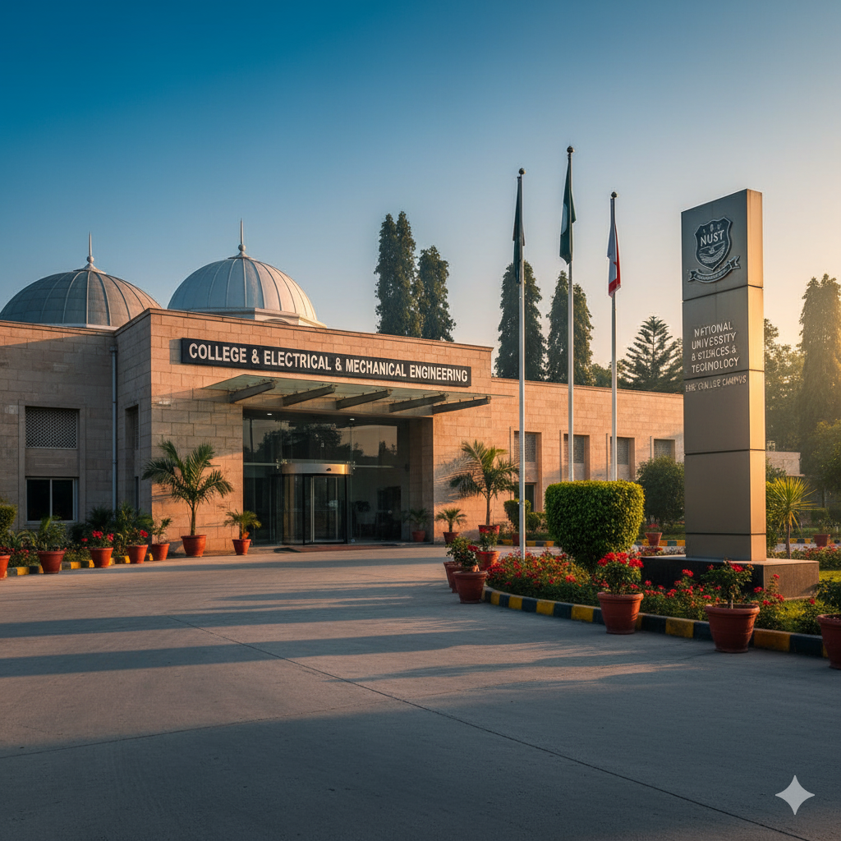

**OUTPUT # 3:**

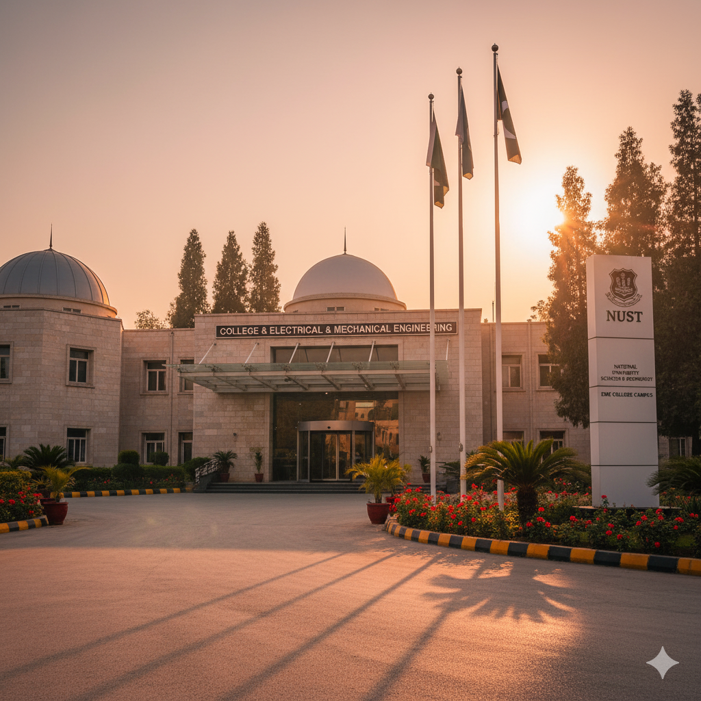

**OUTPUT # 3:**

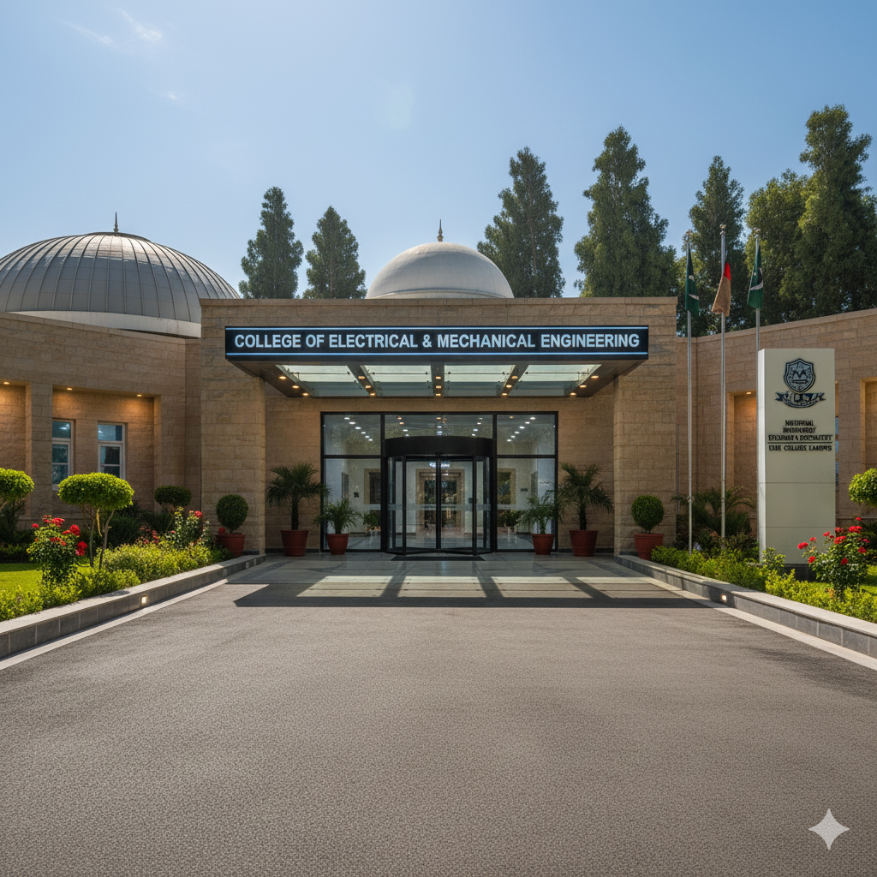

**OUTPUT # 4:**

